Lab 1 - Signal Operations

EE-3221/051 Digital Signal Processing

Dr. Marek Trawicki

By: Andrew Iliescu, Eduardo Diaz, & Than Win

19 December 2019

Introduction

Sound clips are a great example of discrete-time signals and by adjusting the frequency/period by using signal operations, those sound clips are changed. Whether this be made to speed up, slow down, or change the pitch, many different types of adjustments can be applied. The signal operations used are amplitude scaling, time reversal, time scaling, time shifting, and amplitude shifting. This laboratory project utilized MATLAB to apply several signal operations to the input discrete-time sound signals, and then they were analyzed to study the impact on the output signals.

Procedure

Materials:

* Laptop with MATLAB Software
* Earbuds or headphones

MATLAB Procedure:

* Load and listen to the chirp sound clip using the load and sound commands
* Graph the chirp as discrete-time signals and continuous-time signals
* Label the appropriate quantities on the plot
* Apply an amplitude scaling operation to the chirp discrete-time input signals
* Listen to the modified sound clip and plot the signals on the graph, labeling appropriate quantities, and commenting on the results
* Repeat the last two steps but for a time reversal, time scaling, time shifting, and amplitude shifting signal operation.

Results

By using the load and sound commands in MATLAB, the ‘chirp’ sound clip. This produced a 2-second sound clip of a chirping bird. The files were loaded as a variable ‘S’ which allowed to be used in the commands and to be used to access it’s information by using the ‘.’ operator. By using the dot, other variables were able to be assign the sampling frequency and the y-axis values. The other variables were then used to plot Figure 1, which shows the discrete-time and continuous-time graph of the two, set to be programmed as ‘stem’ and ‘plot’ graphs, respectively.



Figure 1: Discrete and Continuous Time Signals of the Original ‘chirp’ Sound Clip

The sound clip then went through an amplitude scaling (100) signal operation where is produced a higher-pitched sound clip. The amplitude was scaled by 100, and as shown in Figure 2, it plots the same graphs as Figure 1 but with the scaled amplitude. Amplitude scaling is used to increase or decrease the intensity of a signal.



Figure 2: Amplitude Scaled Discrete and Continuous Time Signal Plots of the ‘Chip’

Next, the sound clip went through a time reversal which resulted in a revered sound clip, and plots that are horizontally flipped signals of Figure 1. The ends of the graphs in Figure 1 and the beginning of these graphs.



Figure 3: Time Reversed Discrete and Continuous Time Signal Plots of the ‘Chip’

The sound clip was then time scaled which means that the rate at which the signal was sampled. Time scaling can shorten or lengthen the signal. This It was time scaled by 2 so its samples were either upsampled (expanded) or downsampled (compressed) meaning that the sampling rate doubled or halved. For the upsample, the time axis was doubled resulting in a graph that twice as long and a sound clip that half as slow. For the downsample, the sampling was time axis was halved, and the sound clip was twice as fast. Figure 4 presents that upsampled time scaling sound clip, and figure 5 presents the downsample time scaling sound clip.



Figure 4: Time Scaled (Upsampled) Discrete and Continuous Time Signal Plots of the ‘Chip’



Figure 5: Time Scaled (Downsampled) Discrete and Continuous Time Signal Plots of the ‘Chip’

Next the sound clip was time shifted, so there is a delay before the chirping starts. This delay was created by adding 8192 counts of zero to the front of the sound clip. In Figure 6, the delay is noticeable from the solid line on the axis starting from the beginning to 8192 counts where the sound clip starts. Time shifting can be used to advance or delay a signal.



Figure 6: Time Shifted Discrete and Continuous Time Signal Plots of the ‘Chip’

Last, the sound clip went through an amplitude shift, which controls the vertical location of the graph. For this graph, the signals were shifted upward by 1. Due to this shift, the pitch of the sound clip slightly changed, and the quality was worse than the original. There was some extra noise that muffled the sound of the chirping. The graphs with the amplitude shift are shown in Figure 7.



Figure 7: Amplitude Shifted Discrete and Continuous Time Signal Plots of the ‘Chip’

Conclusions

In conclusion, the laboratory was a success because MATLAB was used to analyze the impact that the several signal operations have on the ‘chip’ sound clip. The amplitude scaling increased the intensity by the given factor; the time reversal flips the signal so the end becomes the start of the new signal; the time scaling shortens or lengthens the signal by the desired value, time shifting creates an advancement or delay of the signal; and amplitude shifting adjusts the base vertical location of the signal (move the signal up or down). These signal operations are very common and having a good understanding of them allows for someone to have the ability to manipulate the output of any signal to their liking. This was can used for modifying audio, video or a circuit involving digital signals.

Questions & Answers

1. Load and listen to the original built-in discrete-time input signal  called handel into the Command Windows using the load and sound commands in MATLAB. Graph the handel signal as the discrete-time input signal  (continuous-amplitude versus discrete-time) and continuous-time input signal  (continuous-amplitude versus continuous-time) using stem and plot commands in a 2x1 plot. Label all appropriate quantities on the plots. Comment on the results.

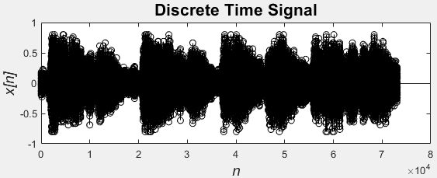

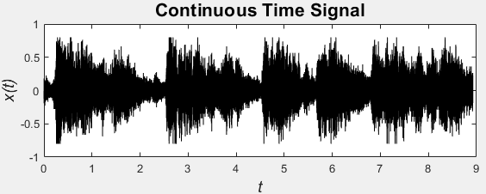

Figure 8: Discrete and Continuous Time Signal Plots of the ‘handel’ Signal.

The results of plotting the “handel” signal in both discrete time and continuous time provided the graphs below in figure 8. Comparing the chip graphs in figure 1 to the handel graphs, one can see the difference in the spacing between significant amplitudes. This is due to the handel signal being more complex.

1. Given the handel discrete-time input signal , apply the signal operation of time scaling in (1) for the parameter *c*. Table 2 displays the signal operation, equation, parameters, and MATLAB commands for the transformation of the handel discrete-time input signal .

|  |  |  |  |
| --- | --- | --- | --- |
| **Signal Operation** | **Equation** | **Parameter** | **MATLAB Command** |
| Time Scaling | *y* *n*  *x**cn* | *c*  2 | upsample |
| *c*  2, 4, 6 | downsample |

Listen to the transformed discrete-time output signals  using the sound command. Graph the continuous-time input signal  (continuous-amplitude versus continuous-time) and transformed continuous-time output signal  (continuous-amplitude versus continuous-time) using the plot in 2x1 (upsample) and 2x2 (downsample) plots. Label all the appropriate quantities on the plots. Comment on the results.

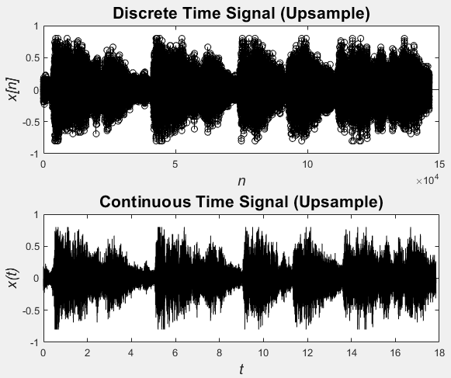

Figure 10: Discrete and Continuous Up Sampled Time Signal Plots of the ‘handel’ Signal.

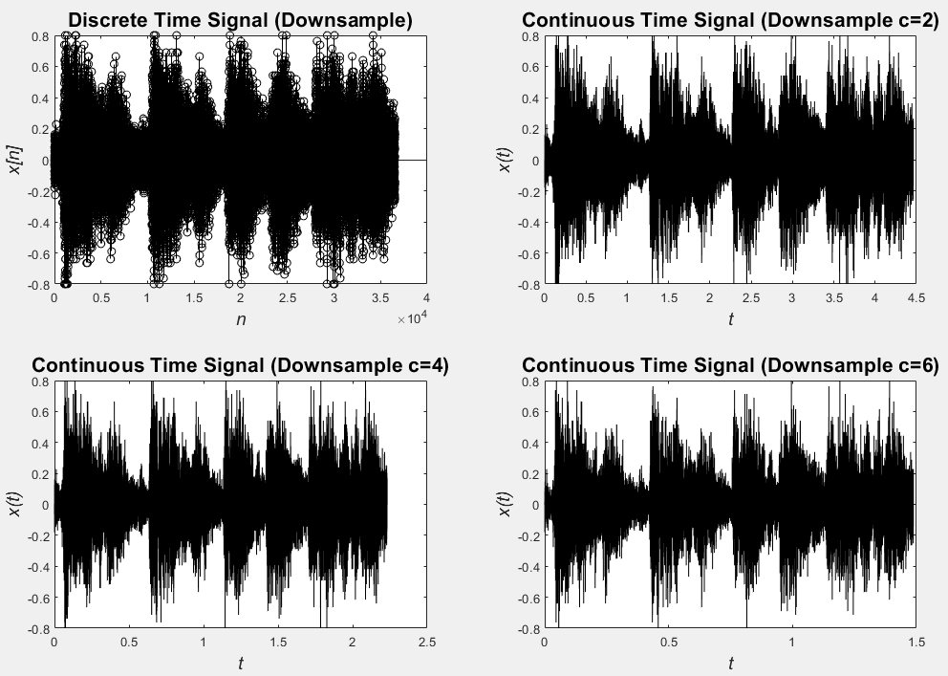

Figure 10: Discrete and Continuous Down Sampled Time Signal Plots of the ‘handel’ Signal.

Time scaling the signal had the desired effect. When you Up sample the signal and increase the time by a constant the signal sounds much slower and lower pitch. The opposite is true when the signal is down sampled. When the time is decreased the signal sound faster and higher pitched.

Supplementary Materials

